SECTION FD

AUXILIARY DRIVES GEAR TRAIN

CONTENTS

General

Chapter

1

2

3

4

5

1. 7

Governor Drive

Coolant Pump Drive and Centre Bearing

Fuel Pump Idler Gears

Main Idler Gear

Inspection

Special Tools ..

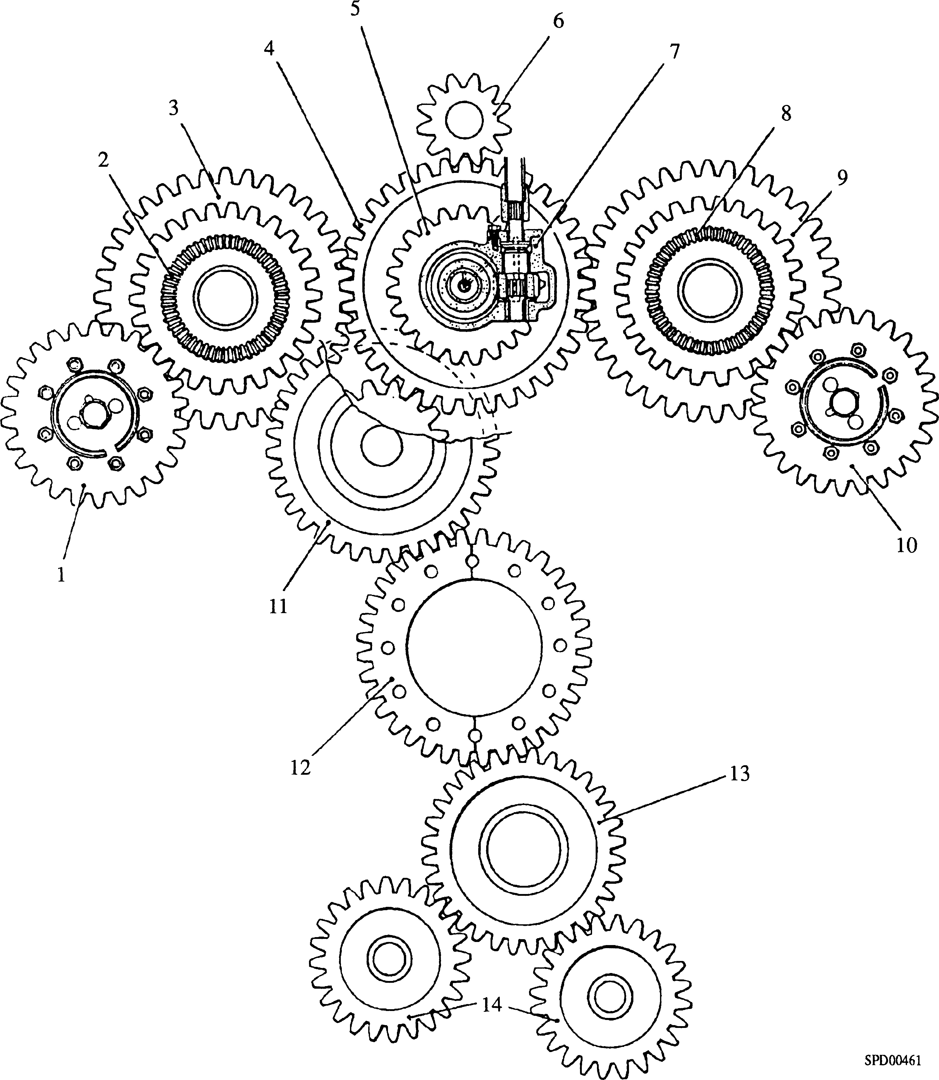

|  |  |  |  |
| --- | --- | --- | --- |
| Key To Numbers  1. Fuel pump camshaft drive gear 'B' bank | | 8. | Bevel gear, overspeed trip drive |
| 2. | Bevel gear for tacho-generator drive | 9. | Fuel pump idler gear 'A' bank |
| 3. | Fuel pump idler gear 'B' bank | 10. | Fuel pump camshaft drive gear ’A’ bank |
| 4. | Engine camshaft drive gear | 11. | Main idler gear |
| 5. | Governor drive gear | 12. | Crankshaft gear |
| 6. | Coolant pump drive gear | 13. | Idler gear, oil pump |
| 7. | Governor drive assembly | 14. | Lubricating oil pump drive gears |

Fig FD.l Arrangement of drive-end gear train

CHAPTER 1

GENERAL

1. The gear train for the auxiliary drives (Fig FD.l) is carried in a compartment at the drive-end of the engine. The drives in the gear train covered in this section are:-
2. Main idler gear.
3. Fuel pump idler gears, 'A' and 'B' bank.
4. Governor drive, including the reduction gearbox.
5. Coolant pump drive (which forms part of the drive-end camshaft bearing

housing), and the centre bearing.

1. The remaining drives are covered in the Sections as detailed below:-

Fuel pump camshafts Section GG

Lubricating oil pump Section JC

CHAPTER 2

GOVERNOR DRIVE

Removal (Fig FD.2)

* 1. Release electrical connections to the governor (Refer to Section HA).
  2. Remove fuel injection pump transverse linkage (Refer to Section HC).
  3. Remove securing nuts and lift off the governor. Withdraw drive shaft (1)
  4. Release nuts and capscrews securing governor mounting cover to the crankcase and lift off the cover complete with guide tube (33).
  5. Bend back tabwashers (25) and remove setscrews (26) securing support bracket (24) to stubshaft (20).
  6. Bend back tabwashers (28), remove two bolts securing locking plate (23) and remove the plate. Remove camshaft location bolt (21) and dowty washer (22).
  7. Bend back tabwashers (28) and remove remaining bolts (27) securing stubshaft (20) to drive housing (13).
  8. Bend back tabwashers (30) and remove setscrews (29) securing stubshaft (20) to crankcase (37).
  9. Support drive housing (13) and governor drive gear (7) within the crankcase, withdraw stubshaft (20) and lift out the complete drive assembly. Remove distance piece (8) from thrust collar (36). The governor drive gear is now unsupported and may be withdrawn from the drive housing.

Dismantling

* 1. Bend back tabwashers (6), remove setscrews (5) and lift off thrust plate (2) and shim (4).
  2. Press spindle (3) upwards out of the housings and remove helical gear (14).

NOTE 1. Do NOT remove bearings (12) or (15) unless renewal is necessary.

1. DO NOT ATTEMPT to ream or scrape the bearings as this will destroy the special bearing surface. If the bearings are badly scored, renew.

Assembly

NOTES 1. The following procedure is based on the assumption that the governor drive has been completely dismantled for the renewal of component parts.

1. All joints and ’O’ rings must be fitted dry.
   1. Press bearing (15) into flanged bush (16), ensuring that the upper edge of the bearing is below the chamfer of the flanged bush. Press the flanged bush into drive housing (13).
   2. Press bearing (12) into drive housing (13), ensuring that the bush is flush with the bottom of the housing recess.

Key To Numbers

1. Drive shaft
2. Thrust plate
3. Drive spindle
4. Laminated shim
5. M6 setscrew
6. Tabwasher
7. Governor drive gear
8. Distance piece
9. Split bush
10. Distance piece
11. Split bush
12. Bearing
13. Drive housing
14. Gear - helical
15. Bearing
16. Flanged bush
17. Dowel - stubshaft to crankcase
18. 'O'ring
19. Dowel - stubshaft to drive housing
20. Stubshaft
21. Camshaft location bolt
22. Dowty washer
23. Locking plate
24. Support bracket - perception head
25. Tabwasher
26. M8 setscrew
27. M8 setbolt
28. Tabwasher
29. M8 setscrew
30. Tabwasher
31. M8 setscrew
32. Locking plate
33. Guide tube - oil deflector
34. Camshaft gear
35. Camshaft
36. Camshaft thrust collar
37. Crankcase
38. Spring clip - for dowel

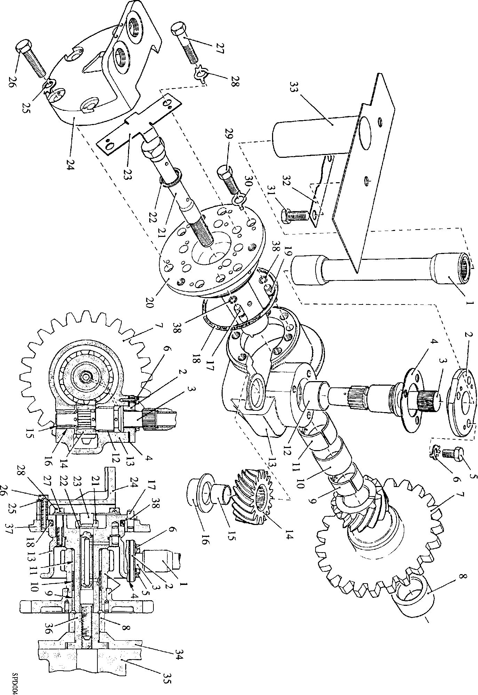

Fig FD.2 Governor drive

* 1. Place helical gear (14) in position, grooved face uppermost and insert spindle (3) from the top of the housing. Fit laminated shim (4) and thrust plate (2) and temporarily secure with setscrews (5). Check the end float of the spindle. This should be 0.004 to 0.008 in (0.10 to 0.20 mm). Adjust as necessary by stripping laminations from shim (4). Finally secure the thrust plate with setscrews and tabwashers (6).
  2. Fit split bushes (9) and (11) and distance piece (10) to the governor drive gear (7).

Check that bush (11) at the helical gear end of the unit is below the chamfer in the

bore.

* 1. If a new governor drive gear (7) and/or helical gear (14) are being fitted, assemble

stubshaft (20) and housing (13), securing with setscrews (27). Place the gear unit

on the stubshaft and check the teeth for bottoming. Horizontal end float should be

1. 005 to 0.020 in (0.127 mm to 0.508 mm).

Fitting

* 1. Rotate camshaft thrust collar (36) to position the drive slot in the end of the collar horizontally. This will ensure correct engagement of the stubshaft drive tongue when fitting.
  2. Fit spring clips (38) to dowels (17) and (19) and fit to crankcase (37) and drive housing (13).
  3. Fit new 'O' ring (18) to stubshaft (20).
  4. Place distance piece (8) in position on thrust collar (36).
  5. Insert governor drive gear (7) into drive housing (13), lower the assembly into position in the crankcase and fit stubshaft (20). Care must be taken when inserting drive spindle (3) to avoid damage to the bush bores and to ensure correct engagement of the drive tongue and locating dowels (17) and (19).
  6. Secure the drive housing to the stubshaft with setbolts (27) and tabwashers (28) and the stubshaft to the crankcase with setscrews (29) and tabwashers (30). Apply 'Loctite 275' to the setscrew threads before assembly.
  7. Using a new dowty washer (22), fit and tighten camshaft location bolt (21).
  8. Remove two bolts (27), fit locking plate (23) and re-tighten bolts. Bend up all tabwashers.
  9. Fit support bracket (24), using setscrews (26) and tabwashers (25). Bend up tabwashers.
  10. Fit the governor mounting cover complete with guide tube (33).
  11. Insert governor drive shaft (1) ensuring that it engages correctly with the serrations on spindle (3).
  12. Fit the governor, ensuring that the governor drive spindle engages correctly with drive shaft (1).
  13. Fit the fuel injection pump transverse linkage (Section HC).
  14. Remake electrical connections to the governor (Section HA).

CHAPTER 3

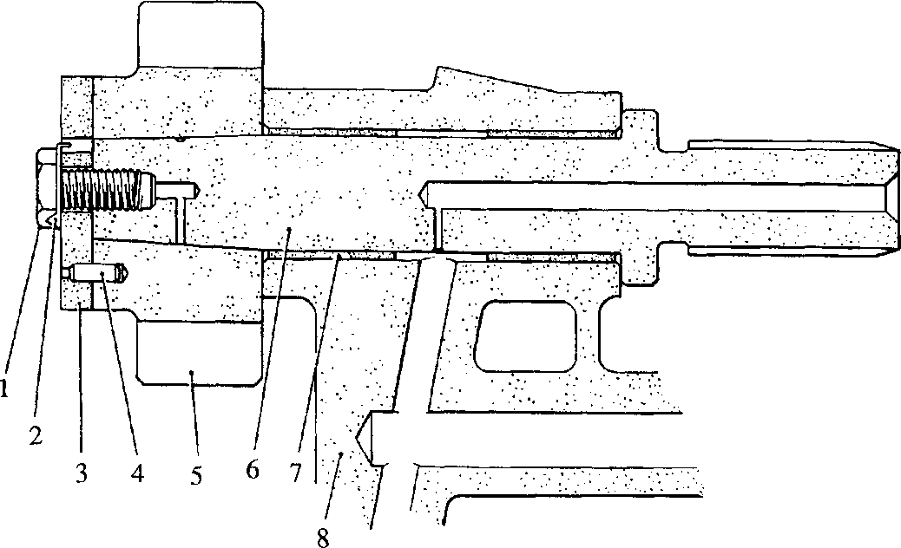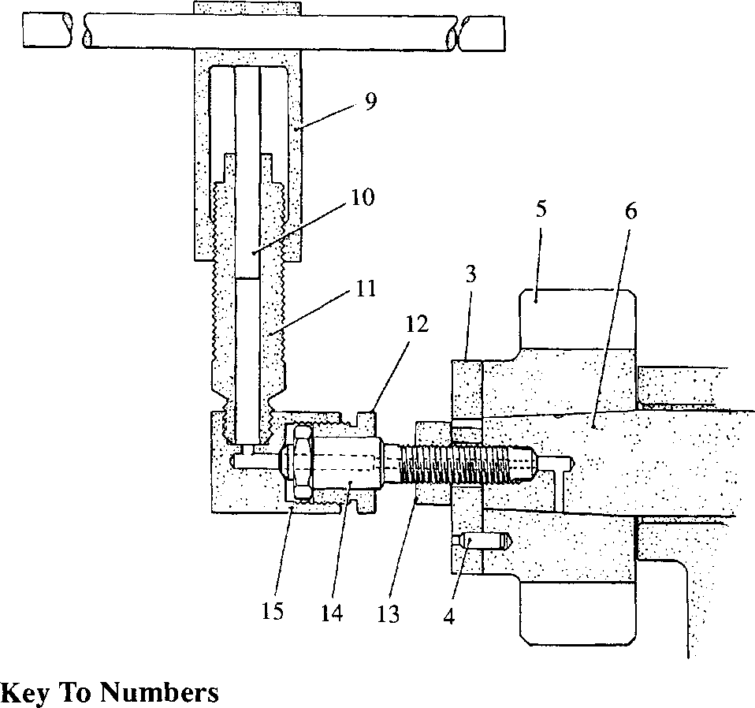COOLANT PUMP DRIVE AND CENTRE BEARING

SPD00457

|  |  |  |  |
| --- | --- | --- | --- |
| 1. | Setscrew | 9. | Pump sleeve |
| 2. | Tabwasher | 10. | Pump plunger |
| 3. | Retaining plate | 11. | Cylinder |
| 4. | Dowel | 12. | Locking nut |
| 5. | Drive gear | 13. | Plain nut |
| 6. | Spindle | 14. | Adaptor |
| 7. | Bearing | 15. | Connector |
| 8. | Housing |  |  |
|  | Fig FD.3 Removing and fitting coolant pump drive gearwheel  LIMITED RIGHTS LEGEND | | |

USE, DUPLICATION OR DISCLOSURE OF THIS INFORMATION WHICH IS THE PROPERTY OF GEC ALSTHOM DIESELS LIMITED BY THE U.S. GOVERNMENT OR BOLLINGER IS SUBJECT TO THE RESTRICTIONS SET FORTH IN DOD FAR SUPP 252.227-7013 (») 15.

1. The coolant pump drive, driven from the camshaft gearwheel, is carried in wrapped bushes in the drive-end camshaft bearing housing. The gear is hydraulically expanded on to a taper on the shaft spindle, and secured by a setscrew and retaining plate. If required, the gear may be removed with the drive in position in the engine, and this procedure is covered in this Chapter. If it is required to remove and dismantle the coolant pump drive with the engine camshaft, refer to Section FC. For centre bearing removal refer to the following text.

Dismantling Gear (Fig FD3)

1. Remove fuel injection pump transverse linkage (Section HC).
2. Referring to Chapter 2 of this Section, remove the governor, drive shaft and

governor mounting cover. This will allow access to the drive gear.

* 1. Bend back tabwasher (2)(Fig FD.3) and remove setscrew (1) and retaining plate (3).
  2. Place locking nut (12) over the plain portion of adaptor (14) and screw on plain nut (13) as far as possible. Place retaining plate (3) over the adaptor stem, screw the adaptor into the end of spindle (6) and tighten firmly. Locate the retaining plate to dowel (4) and screw up nut (13) to retain the plate in position.
  3. Screw cylinder (11) of hydraulic pump into connector (15) and tighten securely.
  4. Place the connector over the end of the adaptor, with the pump cylinder vertical and

secure with locking nut (12). Slacken back plain nut (13) approximately 1/2 turn.

NOTE The hydraulic pump is designed for use with gear oil SAE 140 or similar. In some instances leaks at the various joints or at the shaft taper may render the tool ineffective. This can be overcome by thickening the oil with clean grease, or using grease alone in the tool, provided all air pockets can be eliminated.

* 1. Partially fill the cylinder with clean oil, insert plunger (10) and screw on sleeve (9) until a resistance is felt. Further tightening will cause the oil to be injected between the gear and the spindle, expanding the bore of the gear and allowing it to move down the spindle taper. Continue to screw on the sleeve whilst unscrewing nut (13) until the gear is free. This will be indicated by a loss of pressure at the pump. In certain instances pressure alone may not be sufficient to 'start' the gear, in which case the gear can be given a sharp tap with a plastic mallet to release its grip on the shaft.

CAUTION NUT (13) MUST NOT BE SLACKENED OFF MORE THAN HALF A TURN BEFORE APPLYING HYDRAULIC PRESSURE AS THE INITIAL MOVEMENT IS ABRUPT AND IF THE TRAVEL IS TOO GREAT, DAMAGE MAY RESULT.

* 1. Unscrew locking nut (12) and remove pump and connector. Unscrew and remove adaptor and retaining plate. Remove gear (5) from spindle (6).

Centre Drive - Dismantling and Inspection

* 1. Remove the coolant pump and withdraw free-end cardan shaft (l)(Fig FDA). Bend back tabwashers (3) and remove setscrews (2). Remove the centre drive assembly and drive-end cardan shaft (5). Withdraw intermediate spindle (10) from bearing housing (4).

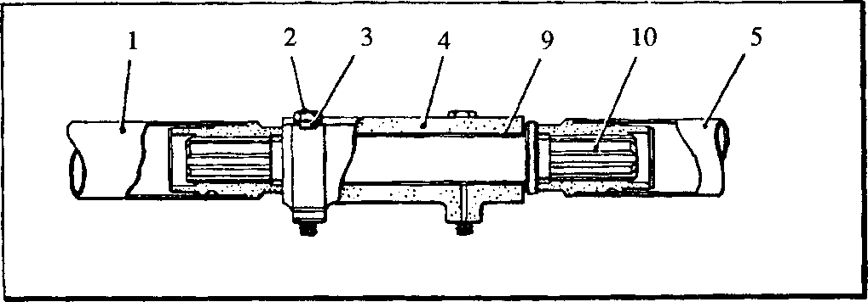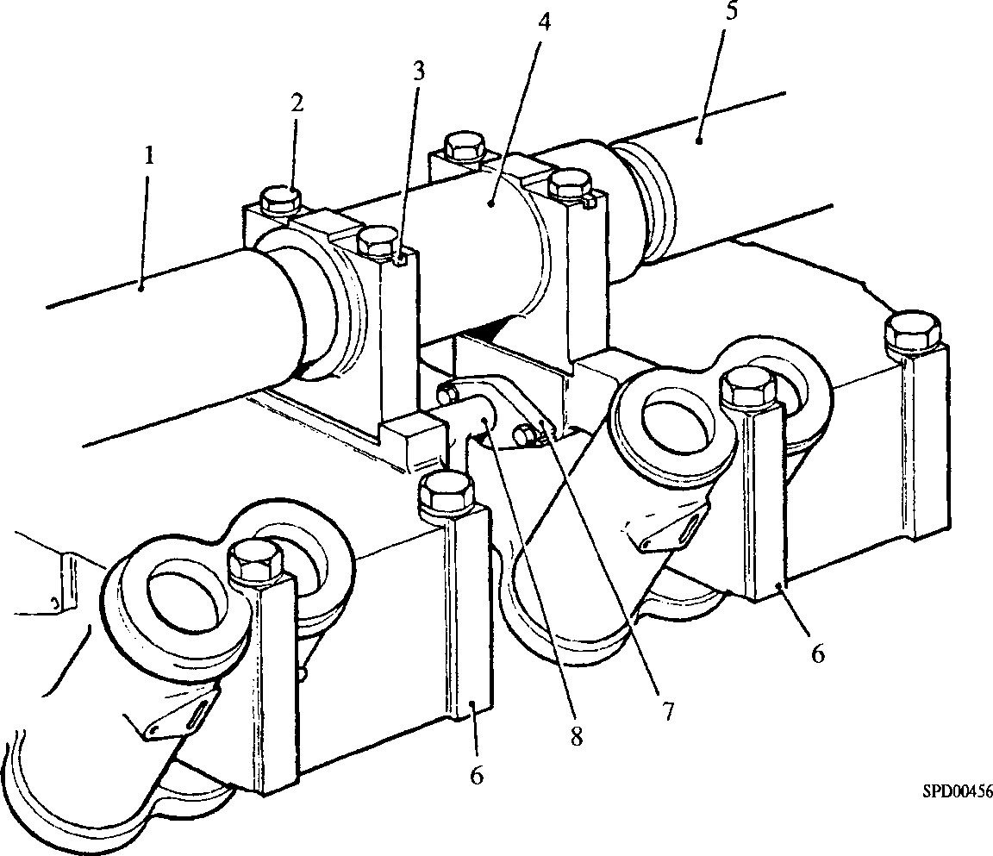Key To Numbers

1. Free-end cardan shaft
2. Setscrew
3. Tabwasher
4. Centre bearing housing
5. Drive-end cardan shaft
6. Centre tappet housing
7. Oil connection flange
8. Oil connection
9. Bearing bush
10. Intermediate spindle

Fig FD4 Centre bearing for coolant pump drive

Check all dimensions against the Schedule of Clearances and Wear Limits (Section CD). If within limits, check all bearing surfaces for scoring and splined portions for fretting and burring; blend out such marks with a fine oilstone.

Assembly

NOTE All joints and ’O’ rings must befitted dry.

1. Worn bushes should be removed and new bushes pressed in ensuring that the outer faces of the bearings are below the chamfers of the housing bore. DO NOT remove wrapped bushes except to renew.
2. Check that the oilways in the housing are clear. Examine the threads of setscrews for serviceability.
3. Press bearings (7)(Fig FD.3) into housing (8). Ensure that the outer ends of the bearings are below the chamfers in the housing bore.
4. Oil spindle (6) and insert into the housing. Clean the bore of the drive gear and the spindle taper and place the gear in position on the spindle.
5. Assemble locking nut (12), plain nut (13) and retaining plate (3) to adaptor (14), screw the adaptor into the end of the spindle and tighten securely. Locate the retaining plate to dowel (4) and screw up nut (13) to force the gear firmly onto the spindle. DO NOT OVERTIGHTEN; a firm pressure is sufficient.
6. Screw cylinder (11) of the pump into connector (15) and tighten securely. Fit the connector to the adaptor and secure with locking nut (12).
7. Referring to the NOTE preceding Paragraph 3.9, partially fill the cylinder with clean oil, insert plunger (10) and screw on sleeve (9) until a resistance is felt. Further tightening of the sleeve will inject oil between the gear and shaft, expanding the gear and allowing it to move up the taper. Whilst applying hydraulic pressure, tighten nut (13) to force the gear onto the shaft. Do not apply undue force to the nut but rely rather on an increase in hydraulic pressure.
8. When the gear has been pressed on the correct distance, retaining plate (3) will butt against the end of the spindle and nut (13) will become solid. Release the hydraulic pressure by slackening back sleeve (9) and check that the end float is in accordance with the figures quoted in Section CD. If the figure is high, unscrew nut (13), draw back the retaining plate and check that the gear is flush with the end of the shaft. If the gear and shaft are not flush the retaining plate may have been held off the shaft by a cushion of oil, wipe away all traces of oil and repeat the fitting procedure. Remove connector (15), and hydraulic pump, and remove adaptor (14).
9. Fit retaining plate (3) and secure with setscrew (1) and tabwasher (2). Tighten the setscrew to a torque loading of 50 lbf/ft. Fit cardan shaft (5) (Fig FD.4).
10. Fit new bushes (9) to housing (4). Insert intermediate spindle (10) and fit the centre drive assembly to tappet housings (6). Secure with tabwashers (3) and setscrews (2). Bend over tabwashers to lock.
11. Complete engine re-assembly.

CHAPTER 4

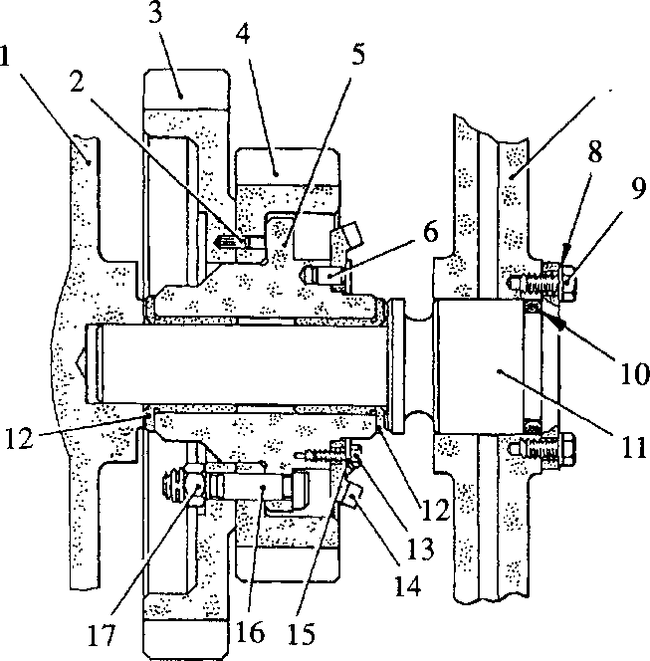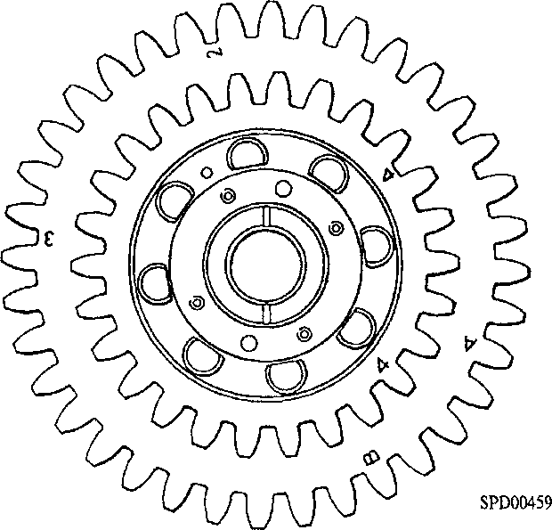FUEL PUMP IDLER GEARS

Key To Numbers

1. Crankcase inner skin
2. 'O' ring
3. Spindle
4. Flanged bush
5. Setscrew
6. Bevel gear
7. Locking plate
8. Fitting bolt
9. Philidas nut
10. Dowel
11. Large gear
12. Small gear
13. Hub
14. Dowel
15. Crankcase outer skin
16. Tabwasher
17. Setscrew

Fig FD.5 Fuel pump idler gear assembly

Removal

1. Remove the engine camshaft (Section FC).
2. Remove 'A' and 'B' bank fuel pump camboxes (Section GG).
3. Remove the overspeed trip unit and drive (Section HC).
4. Bend back tabwashers (8) (Fig FD5) and remove setscrews (9) securing 'A' bank idler spindle (11) to crankcase (7).
5. Assemble the extractor (Fig FD.6) to the spindle, screwing centre screw (7) into the spindle and squaring thrust plate (3) to the crankcase by means of jacking screws (2). Tighten locknuts (4). The thrust plate should be positioned as shown at 'C'.
6. Support the gear assembly through the side and top crankcase apertures and withdraw the spindle by tightening nut (1). Remove the gear assembly through the top aperture.

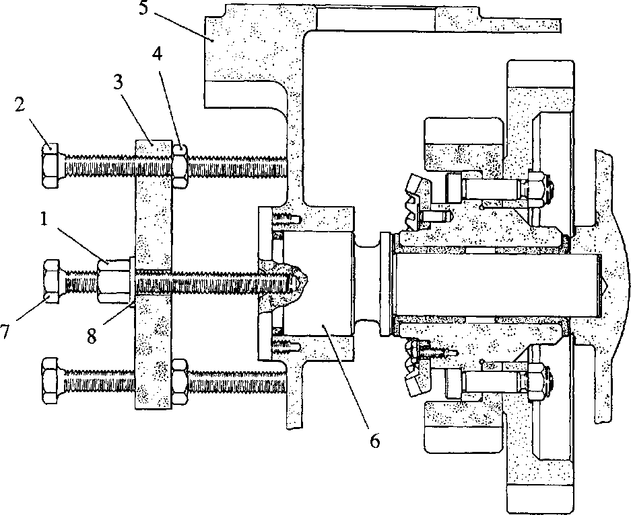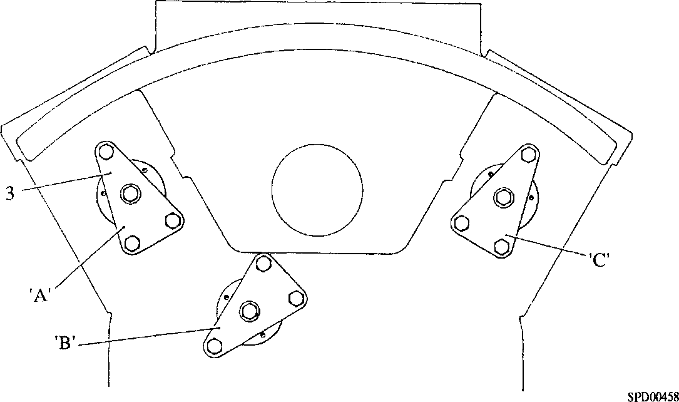

Key To Numbers

'A' Tool position withdrawing 'B' bank fuel pump idler spindle 'B' Tool position withdrawing main idler spindle 'C' Tool position withdrawing 'A' bank fuel pump idler spindle 'D' Not Used on this engine

1. Withdrawal nut
2. Jacking screw
3. Thrust plate
4. Locknut
5. Crankcase
6. Idler spindle
7. Centre screw
8. Washer

Fig FD6 Method of removing drive-end idler gear spindles

1. Repeat for 'B' bank idler assembly, positioning thrust plate (3)(Fig FD.6) as shown at 'A'.

Dismantling

1. Bend back locking plates (15)(Fig FD.5), remove setscrews (13) and draw bevel gear (14) off hub (5). Release nuts (17), tap out fitting bolts (16) and remove gears
2. and (4) from the hub (5).Key To Numbers

Assembly

NOTE All joints and *0* rings must be fitted dry.

1. Press flanged bush (12) into hub (5), ensuring that the bush flanges contact the faces of the hub. The bearing bores are not pre-finished and therefore it will be necessary to broach, ream or fine turn the bores to the dimension quoted in Section CD. This will also ensure correct alignment of the bearing bores.
2. Place gears (4) and (3) on hub (5) ensuring that locating dowel (2) between the two gears is correctly engaged. Insert fitting bolts (16), fit nuts (17) and tighten to the torque loading quoted in Section CE.
3. Place bevel gear (14) in position, fit locating dowels (6), position the locking plates (15) over the dowels and insert and tighten setscrews (13). Bend up locking plates.

Fitting

1. Fit new 'O' ring (10) to spindle (11). Insert one gear assembly through the crankcase top aperture to the 'A' bank position and fit spindle. Secure the spindle with setscrews (9) and tabwashers (8). Check that the end float of the assembly is within correct limits.
2. Repeat for 'B' bank position.

CHAPTER 5

MAIN IDLER

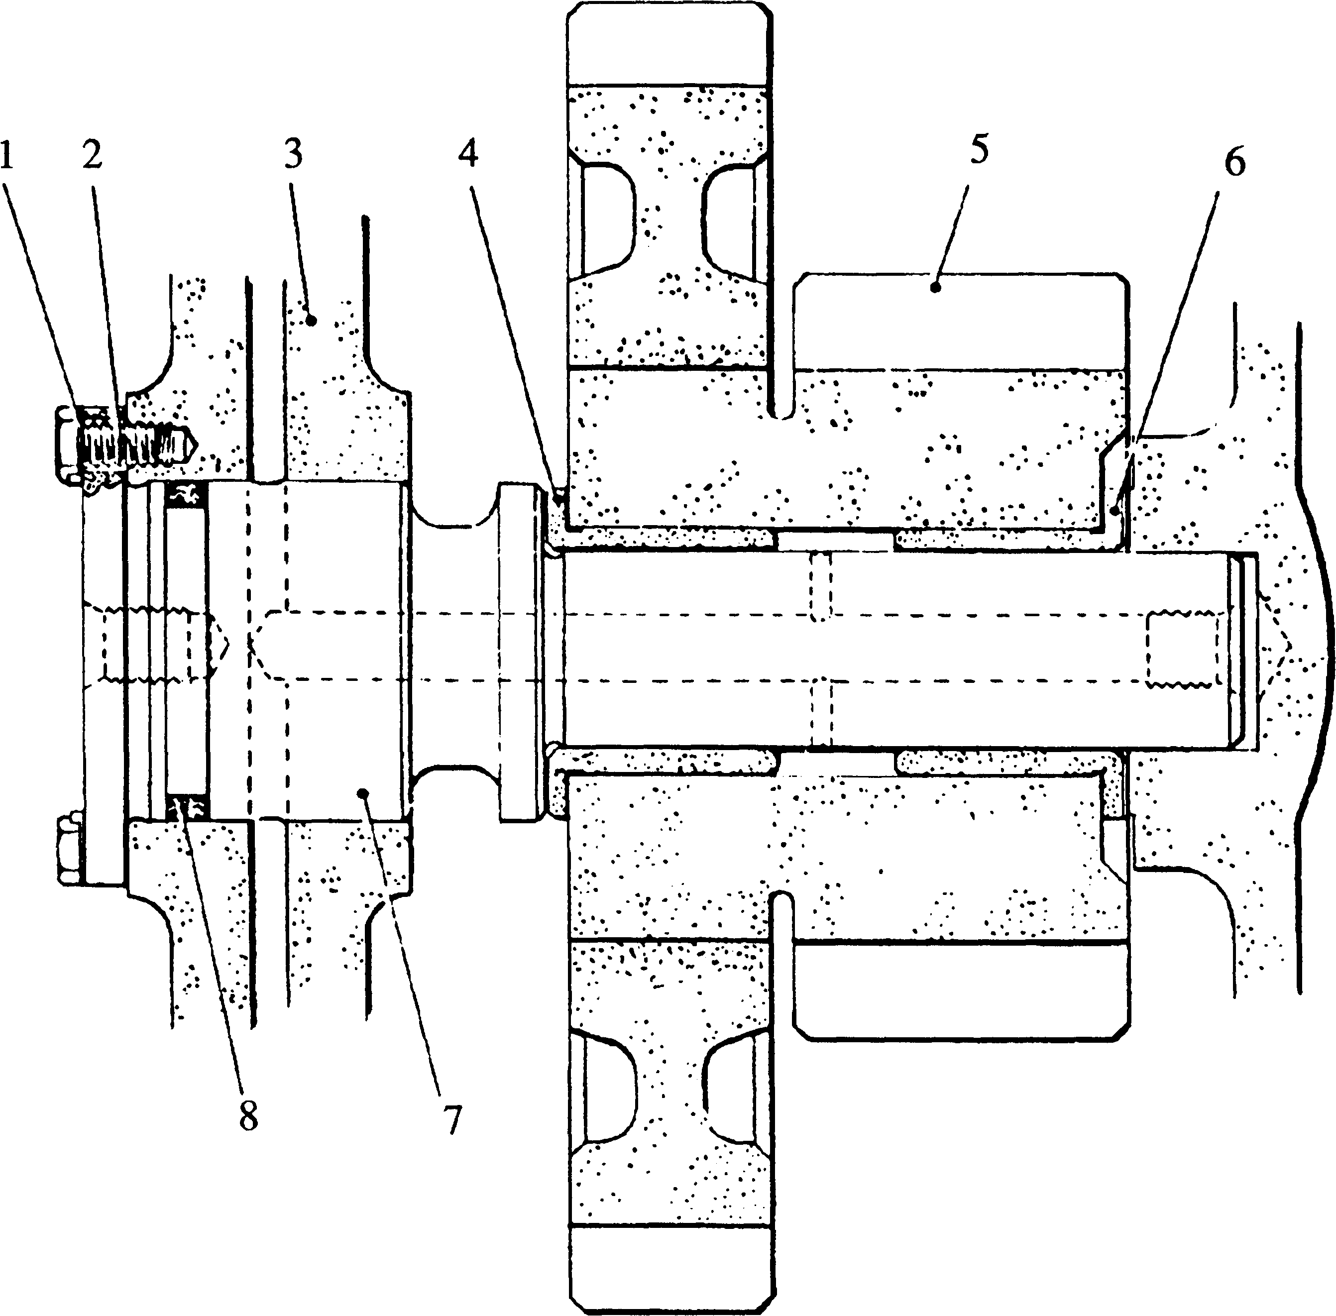

Key To Numbers

|  |  |  |  |
| --- | --- | --- | --- |
| 1. | Tabwasher | 5. | Main idler |
| 2. | Setscrew | 6. | Flanged bush |
| 3. | Crankcase | 7. | Spindle |
| 4. | Flanged bush | 8. | ’O’ ring |

Fig FD.7 Main idler gear

1. This is a plain double gear assembly (Fig FD.7) fitted with two flanged bushes. The gears cannot be separated and therefore other than replacing the flanged bushes no maintenance is possible.
2. The bushes are not pre-finished and will have to be broached, reamed or fine-turned after fitting to the dimension quoted in Section CD. This will also ensure correct alignment of the bearing bores.
3. The removal and fitting instructions are identical to those for the fuel pump idler gears except that the extractor should be positioned at 'B' (Fig FD.6).

CHAPTER 6

INSPECTION

1. All dimensions, where possible, should be checked against those quoted in the Schedule of Clearances and Wear Limits (Section CD).
2. Check the bearing surfaces of all spindles for scoring. Light score marks may be blended out with a fine oilstone. Check that oil holes in the spindles are clear. Measure the diameters.
3. Examine the splined portions of the coolant pump drive and centre drive spindle, and the serrated portions of the governor drive and reduction gearbox shafts for fretting and burring. Clean any such marks.
4. Examine all bushes for scoring. Light score marks may be blended out with a scraper. Measure the bores.

NOTE This does not apply to the D.U. bushes fitted to the governor vertical drive spindle. Bushes of this type cannot be scraped as this would destroy the special bearing surface. Bushes should be renewed if badly scored.

1. Check the gear teeth for ridging, pitting or plucking. Blend out any such marks with a fine oilstone.
2. Examine all threaded components for serviceability. All 'O' rings and tabwashers should be discarded and new ones fitted.

CHAPTER 7

SPECIAL TOOLS

The following special tools are sufficient for carrying out all general maintenance, dismantling, overhaul and assembly operations on the auxiliary drives as detailed in this section. Standard tools, eg. open ended spanners, ring spanners and socket spanners are not mentioned.

NOTE These tools are only shown in the Illustrated Parts List if they if they have been ordered as part of the contract.

|  |  |  |
| --- | --- | --- |
| DESCRIPTION | PART NO | USE |
| Torque wrench 10 to 50 lbf/ft | OD26977 | ) |
| xh in square drive |  | ) To tighten fastenings to a pre- ) determined loading. |
| Torque wrench 50 to 250 lbf/ft | OD28465 | ) |
| V2 in square drive |  | ) |
| Removal tool water pump | Y3J70750 | ) |
| drive gear assembly |  | ) |
| comprising:- |  | )  )  )  ) To remove and fit the coolant pump |
| Locking nut | Y3J70118 |
| Adaptor | Y3J70876A | ) drive gear to its spindle.  )  )  )  ) |
| Connector | Y3J72813 |
| Plain nut | ST317113 |
| Hydraulic pump | OD9342 | Used in conjunction with Y3J70750 to provide hydraulic pressure for the removal and fitting of the coolant pump drive gear. |
| Extractor | Y3J70506 | To withdraw the idler gear spindles from the crankcase. |
| Governor drive alignment tool | Y3J72910 | Used to align the governor drive shaft with the governor drive assembly in the engine housing. |